"Smart play" amusement park APP scheme design

|  |  |
| --- | --- |
| Team name: | Professional team |
| team members: | Hao Boshi, He Yilong, Ding Xiaoran, Cao Yuchen |
| tutor: | ShiYunMei |
| School: | Beijing University of Information Science and Technology |
| The participating groups: | Undergraduate Group B |

**catalogue**

abstract I

Chapter 1: Application requirements scenario analysis 1

Chapter 2: Product Content 3

Chapter 3: Scheme demonstration and design ideas 6

3.1 Scheme demonstration 6

3.1.1 Big data acquisition and storage 6

3.1.2, Big data technology 7

3.1.3 Machine learning technology 7

3.1.4 Neural network technology 9

3.1.5 The Beidou system 10

3.1.6 Front-end development technology 10

3.2 Design ideas 11

Chapter 4: Detailed Design and Visual Effect 15

4.1 Overall technical route 15

4.2 Recommended technical route of class functions 17

4.3 Technical implementation route of navigation functions 19

4.4 Visual effects 20

4.4.1 Visual effects of the home page 20

4.4.2 Detailed renderings of the amusement park 20

4.4.3 Feature function interface design 21

4.4.4 "My" visual effects 22

4.4.5 Look for the visual effects of similar project features 22

Chapter 5: Business Value 24

Chapter 6: Summary 25

reference documentation 26

abstract

With the rapid development of China's economy and society, the tourism industry is also continuing to flourish, and people's requirements for play are also constantly getting higher. They are no longer just watching the scenery and eating delicious food, but hope to satisfy their own unique fun from different aspects, and hope that they can play easily and happily. At present, there is a problem in many scenic spots. The personnel are too dense, so it is difficult to design personalized tourism plans according to the characteristics of different people, and it is difficult for people to enjoy the fun of playing.

According to the application requirements of tourists and the function of existing products, our team designed the "hui play" APP, in addition to provide basic functions, more important is according to the characteristics of tourists and different personalized needs to provide intelligent recommendation, let every visitor can through "hui play" APP for their own personality, enjoy the fun of playing.

Key words: personalized recommendation, big data, machine learning, neural network

Chapter 1: Application requirements scenario analysis

With the increasing improvement of people's life, tourism has become an important way for people's leisure. Tourism APP has become a necessary item for people to travel. Passengers can grasp the latest amusement park information and travel strategies at any time through their mobile phones, enjoy real-time checking the number of tourists, booking tickets and other services, which improves the travel experience and travel efficiency.

Through field questionnaire survey and paper study, it is found that the functions of tourism software in the market, such as Ctrip, Tongcheng and Tuniu, are basically similar. Different brand APPs add different functions according to their own characteristics. However, due to industry competition, all kinds of APPs cannot cover the needs of private customized travel, resulting in scattered functions and inconvenient use. According to the results of the questionnaire survey, passengers are more inclined to form the comprehensive APP. In addition, the main service objects of the APP are the post-80s, 1990s and 2000s. The APP should be optimized based on young people to improve the user experience, such as the feature of dating with your girlfriend.

Through research, we found that the existing mobile APP can not solve some actual scenarios that may be encountered when playing in the amusement park, which are listed as follows:

* Scene 1

Users want to go to the amusement park to play, but when making a choice, because the online information is too discrete, too much information is too miscellaneous, not easy to compare, waste too much time in choosing the play place.

* Scene 2

To the playground but found that the playground is a sea of people, the action is very inconvenient; or just to the amusement park suddenly rain, forget to check the weather before travel.

* Scene 3

Visitors to the first time to a new playground, unfamiliar to you stand in front of the playground sign a face of vacant, confused southeast northwest, don't know what the amusement park is suitable for their own project, wasted good time in struggling to find, could have a happy day, but necessarily wasted a lot of time, the mood suddenly became very depressed.

* Scene 4

Tired of playing, just to the meal point, but to find to the restaurant you are familiar with need to cross half the playground, the original good mood at this time but added angry dissatisfaction.

* Scene 5

Tourists spent a lot of time and energy and finally found the project they wanted to play, but suddenly found a lot of people, and then began to struggle whether to change a project or continue to wait in line. Not only wasted a lot of time, but the final decision was not satisfactory.

* Scene 6

When I went to the playground with my friends, I was not familiar with the project and location of the playground and had different personal interests, so I had different opinions and differences on the projects and paths, which not only wasted a lot of time, but also after playing separately, I wanted to gather but found that I could not find each other.

* Scene 7

You have been in and out of the amusement park, today with his girlfriend to come, to find that the girl to play the project is not particularly clear. Internet for a long time, no effective information. This wanted to show a warm man in front of the goddess, but it seems very powerless.(Both men and women are the same, because the boy is generally responsible for the planning, so use the boy for example.）

According to the above application requirements, we designed the product content of "Hui" amusement park APP as described in the following section.

Chapter 2: Product Content

There are dozens of tourism APPs on the market, covering the functions of ticket purchase, navigation, itinerary, after-sale review, scattered functions, not simple and convenient to use, and lack of lost, wasted time waiting for play items.

To analyze the missing functions and the application requirements of the existing tourism APP, the following solutions are proposed.

* **Solution for scenario 1**

According to the flow of people and hot comments, recommend the most popular playground for customers on the home page, in the order from high to low. There is also a positioning function on the home page. Click to find a nearby playground. The APP can recommend a playground relatively close location according to the real-time location of customers. When users click on the playground, they will have basic information about the playground, including geographical location, ticket prices, business hours, number of visitors in real time, and comments on the playground for users to choose from.

When the user in two or more playground hesitated, the APP will show the playground in the public comments on APP on the top ten most popular comments and scale, and real-time traffic, when the user click on traffic, will pop up a small window, the content is the playground ten days after the historical average flow bar chart, intuitively presented to the user playground information and make a reasonable recommendation.

* **Solution for Scenario 2**

When users decided to go to a playground, APP can real-time weather information, scenic information, including playground real-time number, school spring outing is not within the scope of vision but affects the important factors of the scenic spot people, combined with the playground of traffic data analysis to make a better decision, recommend tourists when traffic less to play, let users to get the best travel experience.

* **Solution for scenario 3**

When users register an account, they receive a simple questionnaire, including personal information such as age, gender, personal preferences and eating habits (users have the right to refuse to fill it out). When users began to play, the APP will according to the user age, gender, personal preferences and eating habits and other characteristics, combined with the analysis of years visitors play project data, and with the fastest speed to help tourists choose location, reasonably arrange a private tourist route, APP will be the most comprehensive information to visitors play route, all kinds of logo, let users have a satisfactory travel experience.

* **Solution for scenario 4**

There are two categories of food recommendation:

First, the travel route should be reasonably arranged according to the arrival time of tourists and the play time of each project. When the meal comes, the users will not be too far away from the restaurant, so as to avoid negative emotions of users.

The other is the micro-navigation of the snack stall. If the user does not want to go to the restaurant, the APP will recommend the snack stall and the route navigation according to the user's relative location.

* **Solution for scenario 5**

The main part of the feature is to find similar projects. If the users play too much in the current project, the APP will recommend the optimal play strategy to solve the queuing problem and save tourists valuable time. The APP will make intelligent recommendations according to the type of the project, the relative distance and the number of real-time visitors of the project, so as to make similar play items for tourists, so as to effectively reduce the queuing time of users and the operation pressure of the project, so that users can get a better play experience.

* **Solution for Scenario 6**

When friends are be fond of inconsistent, APP will according to the playground project layout calculated A comprehensive route, beauty, beauty, both personality, and group belonging, APP for the tourists with the best convergence path, custom team, that is to say on the route both class A people like the project and in the adjacent location is class B people like project, both meet their respective needs, and can make them easier to find each other, can play their common preferences of project, not users because they can't find people and anxious.

* **Solution for scenario 7**

If done with a female (male) friend, The APP will provide life tips for visitors, Full of love, Warm meaning is thick, Like fruit, Shor hats and other details that boys tend to overlook, The APP will combine the information from two people, And through the analysis of the couple's travel project data, Summarize the few items with the best results, To recommend a private travel route, Guaranteed girlfriend satisfaction, For the user to establish a reliable son, warm male image, avoid embarrassment, Add to the romance; If it is a family travel APP will pay more attention to parent-child projects, And planning for relatively safer projects, Add to family cohesion, Let the child play happily and safely all day long.

* **More human content**

The APP will also provide a forum section, where people can take photos and share their travel experiences. When users check, the default is all, but they can screen according to the playground to find the information they need. They can also like, comment, private messages, add friends and other functions to find like-minded travelers.

Most importantly, the APP will record the actual route of each user, and conduct information analysis and data update at the end of each time, so as to provide better services for users in the future travel. The goal of our "Smart" amusement park APP is to give users more choices and better experience.

Chapter 3: Scheme demonstration and design ideas

Our design is based on a mobile APP, featuring internal maps and self-service travel services. Based on big data and machine learning technology, the project can classify the internal attractions and waiting time; recommend different travel routes according to their preferences and habits; and help users to find similar items in the case of excessive waiting numbers.

The feasibility of the above scheme will be demonstrated from the perspectives of data sources, technologies and tools.

**3.1 Scheme demonstration**

**3.1.1 Big data acquisition and storage**

The function implementation of the "Huiplay" amusement park APP largely depends on the data source, and we will collect the data from the following aspects:

1) Collect the total, quarterly and monthly flow of people in recent years;

2) Collect the ticket brushing information at the gate of the playground, including entering and leaving the park;

Under the premise of the official permission of the amusement park, log in the playground ticket background system to collect the historical ticket records of each project of the amusement park, including the daily sale time, ticket type and its quantity;

3) Climbing reviews from various amusement parks from hornet's Nest, Ctrip and other APP;

4) Data were obtained by using questionnaires.

For the public, online access to people's age information, gender, personal preferences (water, exciting, warm, other), the most favorite 3 play items, general play time, I think the most suitable time to play time. Questionnaires can be distributed through WeChat, Weibo and other social APP, and can also be promoted at the gate of the amusement park, so as to be more targeted. The content of the questionnaire "favorite play items" were changed according to the actual information of each playground.

In the face of APP users, access to their age information, gender, medical history or fear of advanced physical condition, personal preferences (water, exciting, warm, other), favorite playground, favorite 3 play items, expect to play time, I think the most suitable play time.

Part of the data can be realized through the crawler. Connect the open API of Sesame HTTP software to the API to get different IP addresses, which can effectively avoid the anti-crawler system of the website and realize a more free crawler way.

For Internet crawler tools can use Crawler, DPI. Scribe Is a data (log) collection system developed by Facebook. Also known as web spider, web robot, is a program that automatically grabs the world Wide Web information or script, it supports the collection of pictures, audio, video and other files or accessories.

In addition to the content contained in the network, the collection of network traffic can be processed using bandwidth management technologies such as DPI or DFI.

For big data storage technology, the new database cluster based on MPP (Massively Parallel Processing) architecture, Shared Nothing architecture, combined with the efficient distributed computing mode of MPP architecture, and a number of big data storage technologies such as column storage, large data storage and coarse-grained index. With the characteristics of low cost, high performance and high scalability, it is widely used in the field of data analysis applications. Compared with the traditional database, its PB grade data analysis ability based on MPP products has significant advantages.

**3.1.2 Big Data technology**

Open-source Hadoop was used at the time of the data analysis. Apache Hadoop Is a set of framework for running applications on large clusters built by universal hardware. It implements the Map / Reduce programming mode, where the computing tasks are divided into small blocks (multiple times) and run on different nodes. In addition, it provides a distributed file system (HDFS), where data is stored on computing nodes to provide extremely high cross-data center aggregation bandwidth. When processing the data of user information and project information, the cost accounting can be effectively reduced. Obtain the most accurate data information. This is more conducive to the prediction results of APP and improve the performance of APP.

The APP also uses Hive on the Hadoop platform. Hive is a data warehouse tool based on Hadoop to extract data, convert, and load, a mechanism that can store, query, and analyze large-scale data stored in Hadoop. The advantage of Hive is very helpful for the development of our APP. The advantage of Hive is its low learning cost and fast MapReduce statistics through similar SQL statements, making MapReduce easier without having to develop specialized MapReduce applications. Hive scalable is very good, designed for large data set calculation / extension ability, because we design the APP is to play personnel personal, but the playground data set scale will be in some specific time (such as National Day holiday, Spring Festival, etc.) explosive growth, it is difficult to target to each tourist design personalized play plan, Hive solved this problem.

**3.1.3 Machine-learning techniques**

Machine learning, as a relatively mature technology is very suitable for the development of this APP. There are many algorithms for machine learning, which can be generally divided into supervised and non-supervised algorithms.

The input data in the supervised algorithm is called "training data", and each group of training data has a clear identification or result, such as "spam" and "non-spam" in the anti-spam system, and "1", "2", "" 3 "," 4 " in the number identification, etc. When building the prediction model, supervised learning establishes a learning process that compares the prediction results with the actual results of the "training data", and constantly adjusts the prediction model until the prediction results of the model reach an expected accuracy.

Typical supervised learning algorithms include: K-nearest neighbor, decision tree algorithm, naive Bayes algorithm, etc. These algorithms can solve the prediction problems well in practical applications according to different application requirements and data characteristics. For example, according to the characteristics of supervised learning algorithm, supervised learning can be used to solve the prediction problems such as people flow prediction.

In unsupervised learning, the data is not specifically identified, and the model is learned to infer some intrinsic structure of the data. We can use unsupervised learning to solve the clustering problem, that is, to classify items through the maximum common points of items.

Typical unsupervised learning algorithms are: k-mean clustering (k-means), hierarchical clustering (Hierarchical Clustering), density-based clustering Mean Shift, etc. These algorithms also solve the problem of project classification well. For example, through the k-means method, the algorithm is used to classify the internal positions of the project according to the European distance, to provide support for the following recommendation functions.

Linear regression and logistic regression algorithms are widely used algorithms and can be used to solve some problems in personalized recommendation.

* **linear regression**

Regression is an important problem in supervised learning, and regression is used to predict the relationship between input and output variables. The regression model is exactly the function that represents the mapping between the input variable to the output variable. Linear regression is a kind of regression algorithm. A linear regression of social and economic data can be used to predict a person's income. Similarly, a linear regression of a set of amusement visitor volume data can be used to predict the trend of annual traffic flow and then visually processed. Based on the results of machine learning, the APP will recommend the popular playground to the users.

Model definition:

loss function:

* **logistic regression**

Logical regression is similar to linear regression, but instead of predicting continuous output, it classifies the training examples by a set of categories or labels. For example, logistic regression can be used to predict whether the person is married, has children, or has ever been arrested. In a basic sense, logistic regression only answers questions with "yes" or "no" answers, or questions that can be answered with 1 or 0. However, it can be easily extended to the problem of having larger category sets.

distribution function:

loss function:

Using logical regression, the APP can intelligently classify the amusement project information and user information in the data set, and then make intelligent matching, and finally form a private play route. If it is a multi-person travel, we only need to increase the dimension of the analysis model, classify the information of each person in the team, comprehensively consider the analysis results of each person, and then make intelligent matching and recommendation.

**3.1.4 Neural network technology**

BP neural networks can be used as classification, clustering, prediction, etc. There needs to be a certain amount of historical data. Through the training of historical data, the network can learn the implicit knowledge in the data. In this APP, we should first find some characteristics of the data, and the corresponding evaluation data, and use these data to train the neural network. BP neural network is mainly a system gradually improved on the basis of practice, and it is not entirely based on bionics. From this perspective, utility> physiological similarity. Although BP neural network is a very effective computational method, it also has many weaknesses, such as super complex computing, super slow computing speed, and easy to fall into the local optimal solution. Therefore, APP adopts an optimization algorithm based on BP architecture- -Elman algorithm.

For the prediction analysis of visitor volume data, the Elman dynamic neural network was constructed by JeffreyL. A feedback neural network algorithm proposed by Elman. Compared with the BP neural network algorithm, this algorithm is especially good at predicting the dynamic changing time series. Compared with the traditional BP neural network, the maximum feature of Elman neural network is reflected in the setting of its undertaking layer. Because of this, this system has the characteristics of adapting to time-changing, and can directly reflect the dynamic process of system attributes.

In the EMD-BP neural network visitor prediction research mentioned using the Elman algorithm to predict traffic, through the visitor data and network search normalization, after processing, create a prediction model based on Elman neural network, and use the algorithm to determine the selection of six neurons, the results as shown in Figure 1 and figure 2.

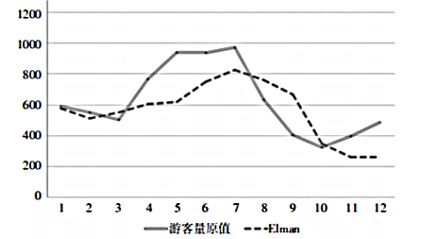

Figure 1 Results for comparing the predicted and actual values of the Elman model

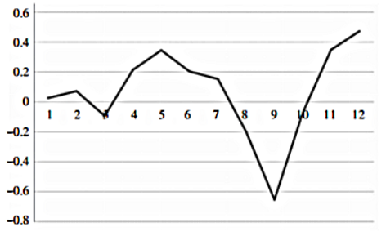

Figure 2 Relative error values of the Elman model

According to Figure 1, the prediction effect of Elman model is better than that of classical BP model; as shown in Figure 2, the relative error distribution of Elman model is more concentrated and smaller; the above experimental results fully illustrate the advantages and feasibility of Elman algorithm, which is more conducive to our analysis to predict the trend of seasonal flow and distribution of amusement parks,

and to recommend alternative amusement parks to tourists.................

**3.1.5 The Beidou system**

The internal map navigation system in the APP will make use of the Beidou system. China's Beidou Navigation Satellite System (BeiDou Navigation Satellite System, BDS) is the global satellite navigation system developed by China and the third mature satellite navigation system after GPS and GLONASS.

BDS consists of three parts: space section, ground section and user section. The four major functions are as follows:

* Short message communication: The user terminal of Beidou DS has the function of two-way message communication, which can transmit short message information of 40-60 Chinese characters at a time
* Precision timing: The Beidou system has the precision timing function, which can provide users with 20ns-100ns time synchronization accuracy
* Positioning accuracy: horizontal accuracy of 100 meters, 20 meters (similar to difference state)
* The maximum number of users accepted by the system: 540,000 households / hour

The most important thing is that the Beidou system provides a free API, and the connected API can use the Beidou system for free. The API can be obtained through CSDN. After connecting to the Beidou system, the APP obtains the precise internal map of the amusement park, allows the users to locate themselves, and obtains the real time of the Beidou system. The short message communication function can also be applied to connect between users and timely obtain real-time information of others. The maximum number of users in the system ensures the remote rotation speed of users at the same time.

**3.1.6. Front-end development technology**

The development front end of "smart play" is Vue.js。Vue. The js is a progressive framework for building a user interface. Unlike other heavyweight frameworks, the Vue uses a design of bottom-up incremental development. Vue's core library, which focuses only on view layers, is not only easy to use, but also easy to integrate with third-party libraries or existing projects. On the other hand, Vue is also fully capable of providing drivers for complex single-page applications when used in combination with single-file components and libraries supported by the Vue ecosystem.Vue. The js is that the build Web, the JavaScript library of the interface, providing data-driven components, and the simple and flexible API that makes the MVVM simpler.key property:

* Scalable data binding
* Take the normal JS object as model
* A simple and clear API
* Component UI build
* Use it with other libraries

After writing the code using vue, you can use the Hbuilder to package the Vue project into a mobile terminal APP, and the Hbuilder will automatically convert the compilation method according to the system of the mobile phone. The specific methods are described as follows:

1) Package vue to dilist directory;

2) Open the dilist directory in Hbuilder;

3) Convert the web items included in dist into mobile APP projects;

4) Conduct real machine debugging on the mobile phone;

5) Package the apk;

6) Install the apk installation package.

**3.2 Design ideas**

The preliminary functions of the APP are set on the basic functions such as ticket purchase and map navigation of the original ordinary APP, adding the recommended play date, internal map, internal food navigation, private customized travel routes and looking for similar items, etc., among which the internal map and private customized travel route recommendation are the main features. The main functions are shown in Figure 3:

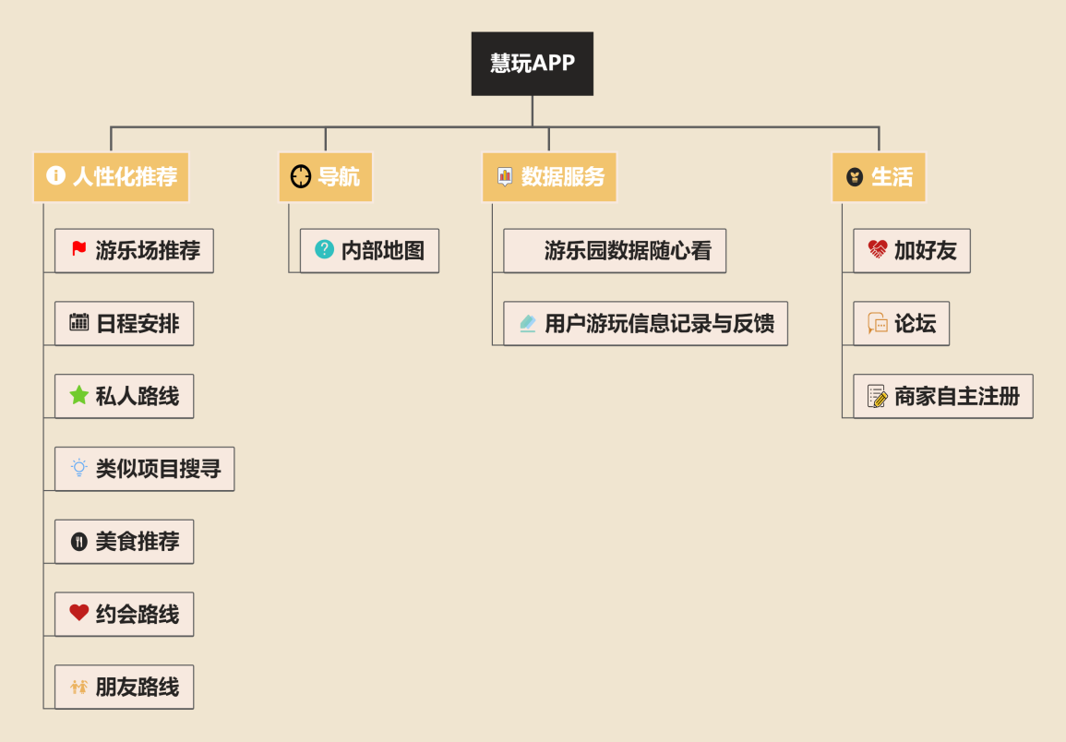

Figure 3 Functional module of the "Hui Play" APP

**1) Intimate service of the internal map**

The internal map based on big data of the APP can get rid of the characteristics of chaotic and error-prone navigation in the scenic APP such as Baidu Map and Amap, and the navigation in the scenic spot is more clear and clear. Different from the GPS positioning system in the market, the APP will adopt the latest domestic Beidou system, which is more accurate. Meanwhile, tourists can report errors and evaluate them after using the navigation, and the system will self-correct them according to the feedback. The internal map also includes the detailed setting of the scenic spot, rest area, store distribution location, and current location to check the basic information and modify the itinerary. Visitors can also check the number, ticket price and waiting time of the scenic spot, and navigate through the 3D display map to understand the situation. Internal map navigation, can provide different navigation voice packages, including star voice navigation packages, to provide users with intimate navigation services.

**2) Professional design of private itinerary**

Before users enter the private trip, the system will automatically form the corresponding travel route according to the basic information such as their own preferences, trip budget, length and time, which can effectively improve the efficiency of tourists and the user's travel experience. Users can further choose special private customized trips, such as traveling with children, and the final route plan is selected by users themselves, which ensures that each user can form a private itinerary plan according to their own preferences and time arrangement, so as to improve travel comfort and economy!

**3) Date with female (male) friends**

This function is specially designed for young people. Nowadays, most men and women travel to watch movies and eat, but a large part of the reason is that it is easy to eat and watch movies, and you don't have to spend too much time planning. This function includes and couples to the playground need to pay attention to the details, behavior, APP will be according to the classification of amusement project, and the analysis of lovers play project, find out the effective emotional project, recommend some more romantic project, reasonable planning route, including where suitable for photo easy to touch female (male), let the user through the APP to achieve love, happy double harvest.

**4) Look for similar projects**

The APP finds projects similar to it according to the classification of the user projects, and recommends them according to the relative location to display the real-time information of the project. For example, the current tour project queue is too many, want to find a less person project; or tourists after playing the project, but also want to look for other similar projects; the APP will give reasonable recommendations.

**5) Humanized recommended playground and travel date**

Before going out, the user can search the destination on the APP platform to obtain the basic information of the destination official introduction, recommendation index and tourist evaluation. After choosing a good destination, they can further get the official strategy and the strategy provided by tourists, and view the evaluation of the tourists to help their own tourism strategy. When the user in two or more playground hesitant, APP will also show the playground on the public comments on the top ten popular comments and scale, and real-time traffic, when the user click on traffic, will pop up a small window, the content is ten days after the playground historical average flow daily bar chart, intuitive presentation to users playground information and make their own recommendation.

**6) Internal food recommendations**

The APP adopts the same method as Amap to register merchants, but the address is no longer a street but in the playground. According to the location of the user, food stalls are recommended from near to far, or tourists can search directly search, and then the APP will provide the route according to the micro-navigation.

**7) Travel trip sharing and comments**

Travel after the APP can enter the BBS section released in play photos and feelings, the content can be simple to a "cool" word, can also be complicated to release a own travel planning, we will show according to the value of the content, provide information for other users, other users can also comment, direct messages to discuss with you.

**8) Add friends**

Users can scan the code, shake or forum to find like-minded travelers, discuss topics about travel, and ask each other about travel planning.

**9) Data recording and feedback after use**

The APP will record the actual route of tourists and the modification of users to optimize the functions of the APP. The APP will also provide a mailbox, in which customers can feedback suggestions or problems to the APP. The APP will timely update data, change parameters and optimize functions.

**10) Look at the data freely**

Referring to the case of Shanghai Disney timely updating various project information, the APP launched the service function of updating journey information at any time. Users can pick up the mobile phone in the scenic spot to check the current traffic flow, traffic congestion and waiting time of the destination according to the situation. The remaining parking space around the scenic spot, the current weather conditions, the play facilities inside the scenic spot can be checked at any time.

**11) Merchants shall register independently**

The businesses here are not just referring to the playground, but all the projects in the playground, they can register at any time. For example, a new food stall has been added in the playground. The stall owners only need to provide their food information and location to the APP to join the big family of the playground. Later, the data of tourists will be updated and told what information has been changed.

Chapter 4: Detailed Design and Visual Effect

**4.1 Overall technical route**

The scheme will adopt the following technical route: data acquisition data storage, data processing data display, as shown in Figure 4.🡪🡪🡪

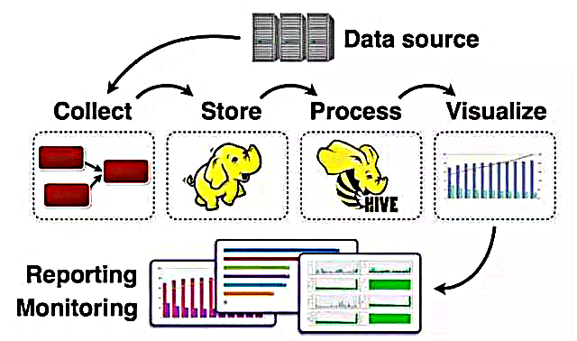

Figure 4 Technical route of the scheme

1. **data collection**

In the process of data collection, data sources will affect the authenticity, integrity of data collection, consistency, accuracy and security of big data quality. For Web data, web crawler is used for collection, which requires the time setting of crawler software to ensure the timeliness quality of the collected data. For example, the value-added API setting of Yihai Poly collection software can be used to flexibly control the start and stop of collection tasks.

For tourist data, online questionnaires and on-site answer papers are adopted. In order to ensure the timeliness of the data, the data is updated by issuing questionnaires again every month. For amusement park data, design a data template that includes the specific information we need, such as internal structure, project play time and other data that is not easy to crawl on the Internet. Each amusement park can upload the information of the amusement park, and carry out subsequent operations such as data integration in the background.

1. **data preprocessing**

Big data acquisition in the process of usually one or more data sources, these data sources include homogeneous or heterogeneous database, file system, service interface, etc., vulnerable to noise data, data value missing, data conflict, etc, so need to first to collect large data collection, to ensure the accuracy and value of big data analysis and prediction results.

The preprocessing process of big data mainly includes data cleaning, data integration, data submission and data conversion through the Hadoop platform, which can greatly improve the overall quality of data collection. Data cleaning technology includes inconsistent detection of data, identification of noise data, data filtering and correction, which is conducive to improving the quality of the consistency, accuracy, authenticity and availability of big data.

Data integration is to integrate the data of amusement parks, amusement park projects and tourist information, so as to form a centralized and unified database, data cube, etc. This process is conducive to improving the integrity, consistency, security and availability quality of big data.

Data reduction is to reduce the size of the data set on the premise of not damaging the accuracy of the analysis results, including dimension reduction, data reduction, data sampling and other technologies. This process is conducive to improving the value density of big data, that is, improving the value of big data storage.

Data transformation processing includes transformation based on rules or metadata, model-based and learning transformation and other technologies, which can achieve data unification through transformation. This process is conducive to improving the consistency and availability of big data.

1. **Data processing and analysis**

1) Data processing

The distributed processing technology of big data is related to storage forms and business data types, etc. The main computing models for big data processing include MapReduce distributed computing framework, distributed memory computing system, distributed flow computing system, etc. MapReduce Is a distributed computing framework of batch processing, which can conduct parallel analysis and processing of massive amusement park and visitor data. It is suitable for the processing of various structured and unstructured data. Distributed flow computing system is to process the data flow in real time to ensure the timeliness and value of the data.

2) Data analysis

Can use Hadoop platform of big data analysis technology such as Hive, at this stage can use distributed mining and deep learning technology, including clustering and classification, correlation analysis, deep learning, mining amusement park data set and tourist data set of data correlation, form the description of things pattern or attribute rules, and then by building a machine learning model and mass training data improve the accuracy of data analysis and prediction.

Through the analysis of the above technology processing APP amusement park flow prediction results and flow distribution characteristics, amusement park project classification and correlation between project information, the pair of tourist data analysis, the APP tourist preferences project type and age and gender association data, combining two data analysis obtained tourists and project matching after the data used to achieve the recommended function.

1. **Data visualization and application link**

The APP visualizes the results of people flow prediction and displays them in the form of line diagram. On the one hand, it can be processed interactively with users. On the other hand, it is beneficial for the APP to find the regular information implied in a large amount of data, such as the trend of annual traffic flow to support the amusement park recommendation function. Data visualization can greatly improve the intuitiveness of big data analysis results, and make it easy for users to understand and use. Therefore, data visualization is the key factor affecting the availability and ease of understanding quality of big data.

Big data application refers to the application of big data results obtained after analysis and processing to the process of function realization and strategic planning. It is the inspection and verification of the above data analysis results. The data application process directly reflects the value and availability of people flow prediction results, project classification, and the data processing results of tourists. Data applications can guide the analysis and processing of the data.

In a variety of data collection, processing and a series of operation before, through the application situation fully research, in-depth analysis of realistic demand information, clear data processing and analysis of the goal is to tourists have a better experience, thus for large data collection, storage, processing, analysis process provide clear direction, and ensure the availability of large data analysis results, value and tourist needs.

**4.2 Recommended technical route of class functions**

The implementation process of the recommendation class is shown in Figure Figure 5.

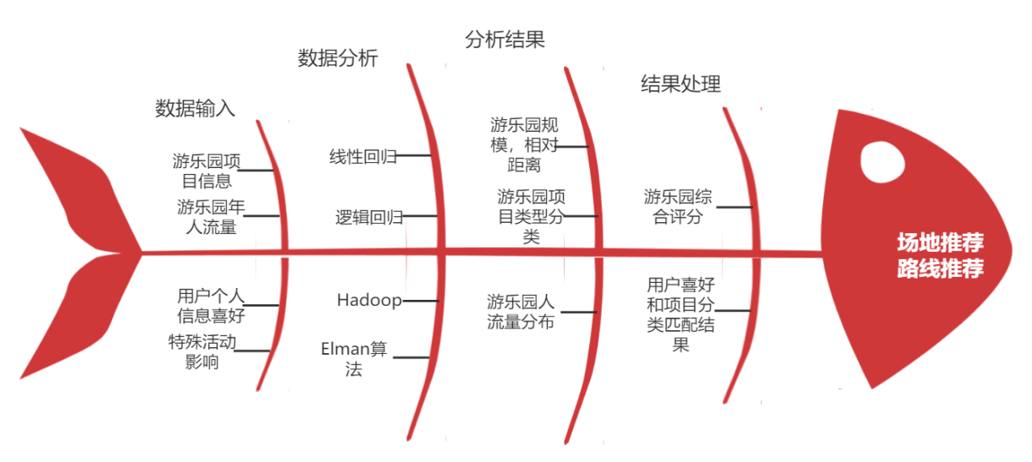

Figure 5 The implementation process of the recommended class function

Recommended functions of the "Smart play" APP:

* Amusement park recommendation
* Travel date recommendation
* Private route is recommended for tourists
* Similar project recommendation
* Internal food recommendation
* Friends travel
* Couples travel

Now take the tourist private route recommendation function and couples travel recommendation function as examples:

The private route function addresses the visitor needs described in Scenario 3, which are dizzy in a strange playground. The specific solution steps are described as follows:

1. Through the amusement park market research, crawler, questionnaire and other forms to collect the required basic information of tourists, hobby project data and amusement park data, including the basic information of the project, introduction, and play time;
2. Store the data into a new database cluster based on the MPP (Massively Parallel Processing) architecture;
3. For amusement park project data analysis, keyword extraction algorithm research results show that the extraction algorithm has TF-IDF, TextRank, LDA theme model, wordVec word clustering algorithm, because the APP required function is relatively simple, so we use unsupervised keyword extraction TF-IDF algorithm from the introduction of each project keyword, according to, logical regression, algorithm analysis project information will project classification, each project can have one or more labels;
4. According to the keywords in the "hobby" column in the project label and the tourist data, and select the items that meet the tourist preferences;
5. Then according to the tourists used to play time, be fond of degree of screening, be fond of degree according to the tourists "hobby" column keywords in the project label appear frequency decision, if the screening out of the project total time to the tourists straw play time does not need to handle, otherwise will according to the project preferences from weak to strong in turn, form the final project group;
6. According to the relative distance with the user positioning, the final project group will finally form the user's private route, and the route will be displayed on the APP for tourists' reference.

The couple travel function addresses the needs of tourists in scene 7, that is, they do not know what items to play with the opposite sex. The specific solution steps are described as follows:

1. First and the amusement park cooperation, when amusement park sell tickets, send links to ask visitors whether love, to love crowd collection they think the most suitable for couples to play project data, to the love crowd they think the most suitable for couples to play project data as expectations for the back of the experimental data;
2. Package experimental data and love project data and store them into a new database cluster based on MPP (Massively Parallel Processing) architecture;
3. Analysis of the labels of love projects and non-love projects obtained by the above way to screen the amusement park projects, and match the amusement park project labels obtained through TF-IDF algorithm and logistic regression analysis in the private route, and the label matching rate is greater than 50% as candidate projects;
4. Combined with the "hobby" keyword of the two people, the candidate project is rescreened, and the screening method is the same way as the private route, to get the final project group;
5. According to the relative distance with the user positioning, the final project group will finally form the user's private route, and the route will be displayed on the APP for tourists' reference.
6. Since some projects belong to the expectations of non-love groups, customers will evaluate and give feedback after the end of each project. According to the feedback results of tourists, the love project data will be collected for data update, and update the data in the database once a month

Travel date recommended according to the algorithm and technology is different, the APP will according to the amusement park history traffic, amusement park special activity date distribution data of amusement park traffic prediction, nearly ten days of traffic through the form of bar intuitive to visitors, at the same time we will give a comfortable index (traffic) for visitors.

**4.3 Technical implementation route of navigation functions**

Navigation function can provide a lot of help when the tourist loses his direction and gets lost. The internal navigation of the APP provides information to every corner of the tourist, taking the tourist to wherever he wants to go. Navigation functions include internal map, location search, search nearby, and other functions, in situ is to the same

When the tourists who use this APP send a message, they will receive your specific location, and then help you solve the problem through private message or meeting.

After receiving the data of the amusement park, the APP will not only analyze the relative distance of the amusement park, but also analyze the category of projects and the distribution information of traffic flow. Combine the amusement park recommended by customers with the above information. At the same time, it will make intelligent matching according to the classification results of play items and users' preferences, so as to create an exclusive route for users.

The specific design route of the navigation class is shown in Figure Figure 6.

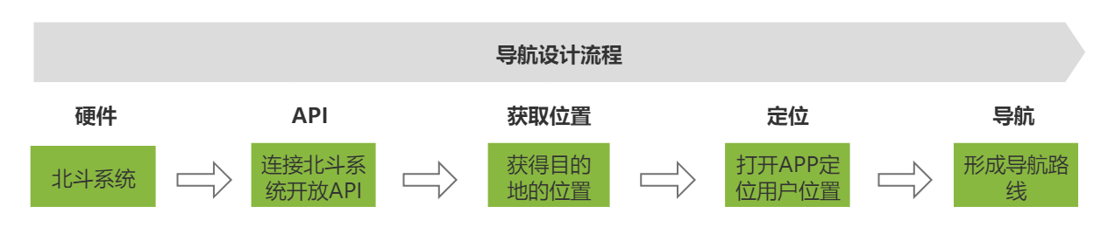

Figure 6 The implementation process of the navigation function

The APP uses the powerful Beidou system to provide technical support for the navigation function of the APP. Accurate positioning and precise timing are the guarantee of navigation accuracy. For looking for similar project function APP combined with the project classification information in the recommended function, intelligently look for similar projects, obtain the positioning of the project, compare the relative distance between the project and the user positioning, and finally form the most reasonable navigation route.

Here to find a similar project features as an example to illustrate how to use the Beidou navigation:

Through the beidou system positioning to the location of the user, combined with the internal map of the amusement park to determine the tourist project, then according to the classification of the query, find and the project label coincidence degree higher some projects, to locate the project, get the relative distance, finally according to the choice of the user to user to he want to navigate to the project.

**4.4 Visual effects**

**4.4.1 Visual effects of the home page**

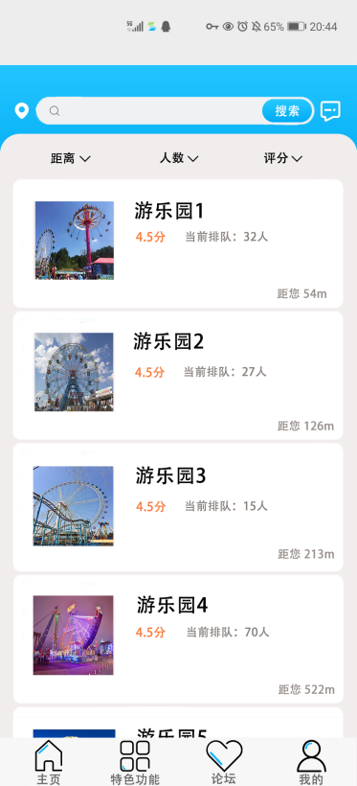

Figure 7 The interface rendering of the home page

As shown in Figure 7, there is a location prompt on the home page, telling the user where they is, and the search box next to the user can directly search the name of the playground or some adjectives. The following is the amusement park recommended by the APP for customers, providing the user with the score of the amusement park, the number of visitors in real time, and the distance. At the bottom are the switch buttons for the different interfaces.

**4.4.2 Detailed renderings of the amusement park**

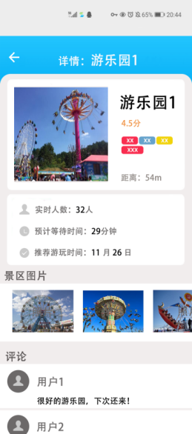

Figure 8 amusement park interface

Users click on the amusement park, will enter the amusement park details interface, in this interface will provide users with amusement park score, classification label, distance, real-time play, expected queuing time, recommend play time, scenic spot pictures, and comment information for user reference, click on the amusement park into the park navigation again.

**4.4.3 Feature function interface design**

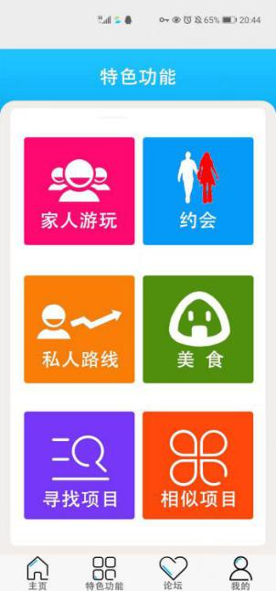

Figure 9. Feature function interface

In the featured function interface, the APP shows the unique functions, so that users can be clear at a glance and find the services they need.

**4.4.4 "My" visual effects**

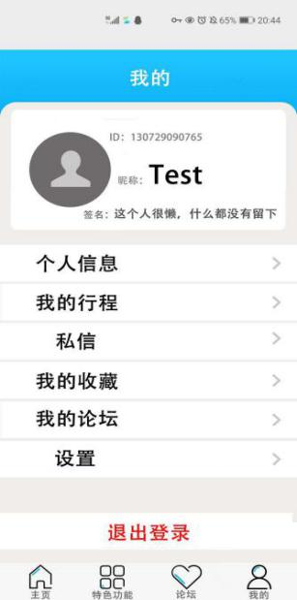

Figure 10 of My user interface

Entering the "My" interface, we will directly show the user id, nickname, signature and other information, in addition to the private message function (click on the information between friends or non-friends), collection, forums and other private functions.

**4.4.5 Look for the visual effects of similar project features**

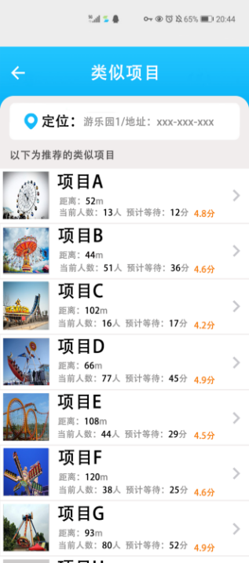

Figure Figure 11 for looking for similar items

After users enter the page of looking for similar projects, the APP will show the recommended projects from the relative distance close to far according to their own calculation. We will provide users with the distance of the project, the number of queues, and the expected waiting time. After clicking on the project, there will be more specific information about the project, such as comments and other information.

Chapter 5: Business Value

Today, the information and digital economy is the future economic direction of China and even the whole world. The development of big data infrastructure, cloud computing, intelligent terminals and other technologies has greatly stimulated the development of informatization and digitalization of the tourism industry. The integration of the Internet and traditional enterprises gradually realizes the transfer of the market from offline to online, stimulating the overall transformation of the traditional tourism industry. The tourism market and the digital media meet, reshape the market trend, guide the development of the tourism industry, so as to promote the diversity of the tourism market development, and provide new historical opportunities for the development of the tourism industry.

"Hui play" is an APP to develop smart tourism, which mainly cooperates with amusement parks. When users go to amusement parks, they do not need to carry out tedious search process, just need to open the APP, enter the service page, that is, they can quickly find the most suitable playground and playground information, clear. After determining the destination of the amusement park, the APP will provide users with services such as private routes, food navigation, and automatic search for similar projects. Through these smart services, customers can use and their choices and consumption data, these data is precious. APP will be in accordance with the amusement park project play, snack day traffic analysis, feedback to amusement park, on the one hand for amusement park, advertising and promotion, on the other hand amusement park can be adjusted according to the APP data, such as increase some tourists love to eat shops, some tourists generally like to play project, attract attention, and then bring great commercial value to amusement park industry chain.

The big data of tourists also accurately shows the address distribution, age section, gender statistics, travel time statistics, consumption content statistics, play time statistics, etc. These numbers are valuable because the gender ratio of visitors improves the playground style to suit mainstream customer preferences, the age ratio tends to be younger or middle-aged, and the visitor area ratio tends to improve meals and services.

Through the segmentation index analysis of big data, in view of the tourism industry and tourists, big data analysis of the rate, average consumption, holiday consumption changes, and the overall rate change, amusement park destination tourists booking habits, play time, consumption content, consumption amount, each time tourism heat analysis, consumption difference analysis, etc., can for industry, scenic spots, tourism management agencies provide real-time data reference, directly improve the management. If improved properly, many companies can usually increase earnings by 20% to 50%.

Chapter 6: Summary

The APP hopes to integrate playground data and tourist information, create a new profession of professional itinerary planner, and generate personal preference information and itinerary design database; At the same time, collect the personal needs and classify the items, and improve the needs to meet the special needs of tourists. Specifically, this scheme has the following advantages:

1) the APP caught the most benefit crowd, young people of a large group, and according to the needs of young people we designed the personality private travel route (audience more than young people), with female (male) friends play characteristic function, this function can not only provide convenience to young people have made friends, more friends for those who are pursuing the opposite sex pointed the way, to some extent the APP can improve the average EQ value of social crowd, improve people's quality of life.

2) the APP navigation system more targeted, through the internal map effectively solve the gold, baidu map navigation problems, at the same time for the first time the machine learning is applied to the navigation system of self feedback, let software optimization, self learning, effectively reduce the waste of human resources, at the same time effectively avoid the human error of adverse consequences.

3) the APP is not only based on the big data, according to the needs of people in the amusement park play, from multidimensional analysis amusement park, provide users with specific amusement park information, excluding the seemingly useful but useless information, but also created a record visitors personal hobbies, age, personality information such as new database, application prospect is very wide.

reference documentation

1. Wang Yan, Yin Guocheng, Sun Maosheng, the design and implementation of the best tour route generation scheme, intelligent processing and application, 2015 (12), 87-89
2. Wu Xiongbin, Guan Hongzhi, Han Yan, random travel time travel route optimization model and its algorithm, Computer Engineering and Design, 2019 (2), 573-577
3. Lu Lijun, Liao Xiaoping, EMD-BP neural network, Statistics and Decision Making, 520 (4), 85-89

[4] Chen Jiaxin, Research on dynamic balance of node load in distributed systems, 2013 (13), Silicon Valley, 1-3